GOLD FACE INSTALLATION

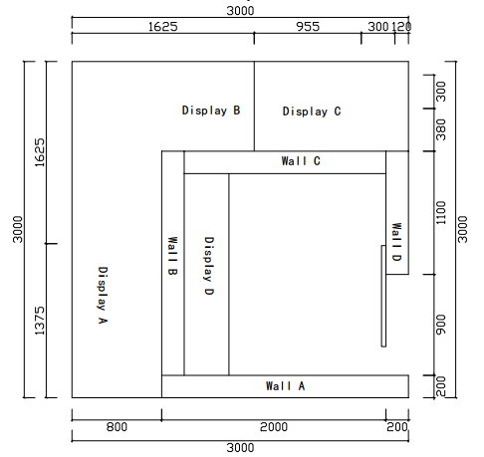
Outside Display installation
Put the display A/B/C in the right location, see plan above.
Remember to connect wire, see photo below.
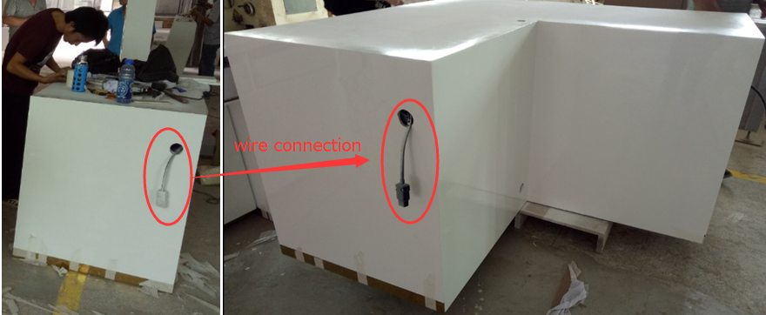
For display B, till counter --- all the keys are in the till counter drawer.
The cube is packed in the right cabinet
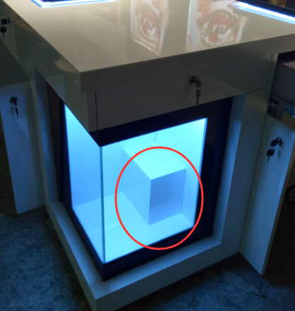
Please open this panel below to put the wood cube.
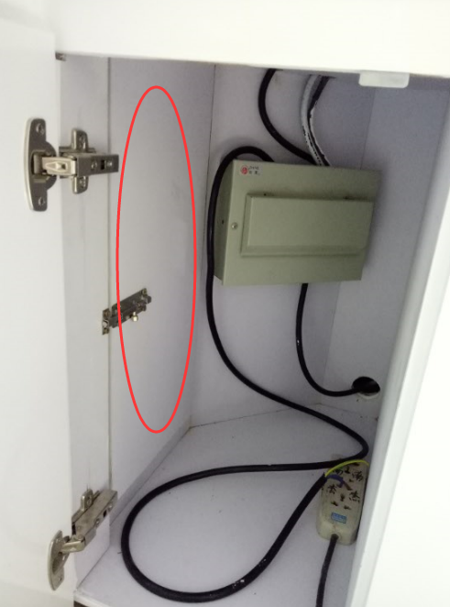

House installation
- Wall connection: A – B – C – D. need 4 people to do it. See video for more details.
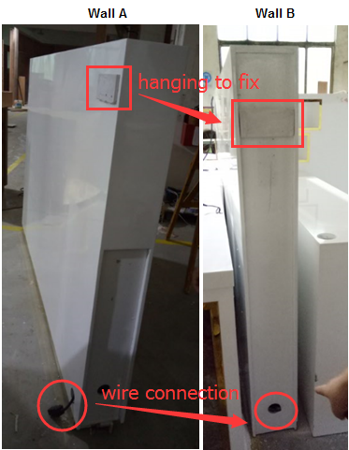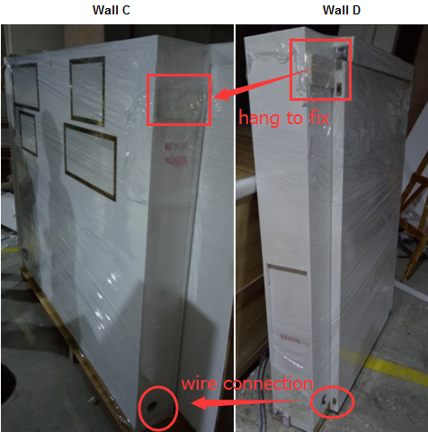
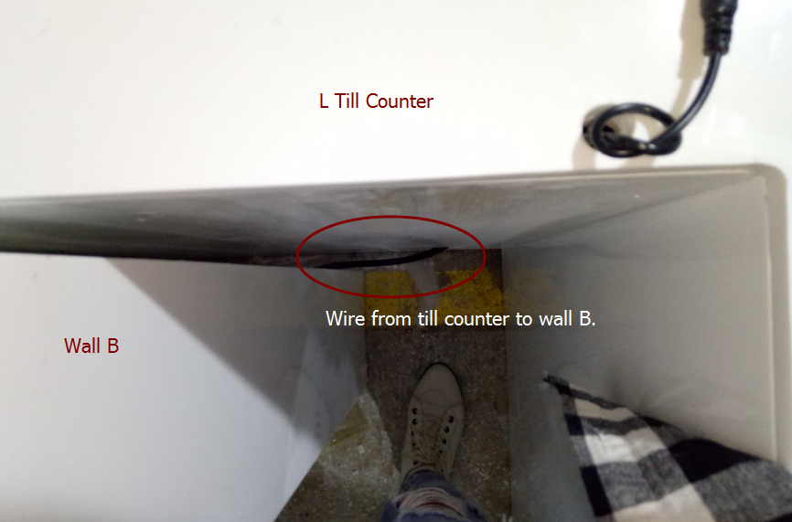

2. Roof
One short pillar located below.
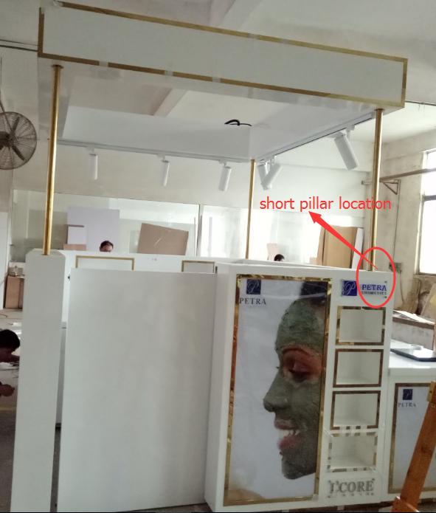

First, put 2 pillar at wall C, remember to put wire through the pillar. See video for details.
https://youtu.be/sjwUzpZcqz4， https://youtu.be/l9c8sXRalEk
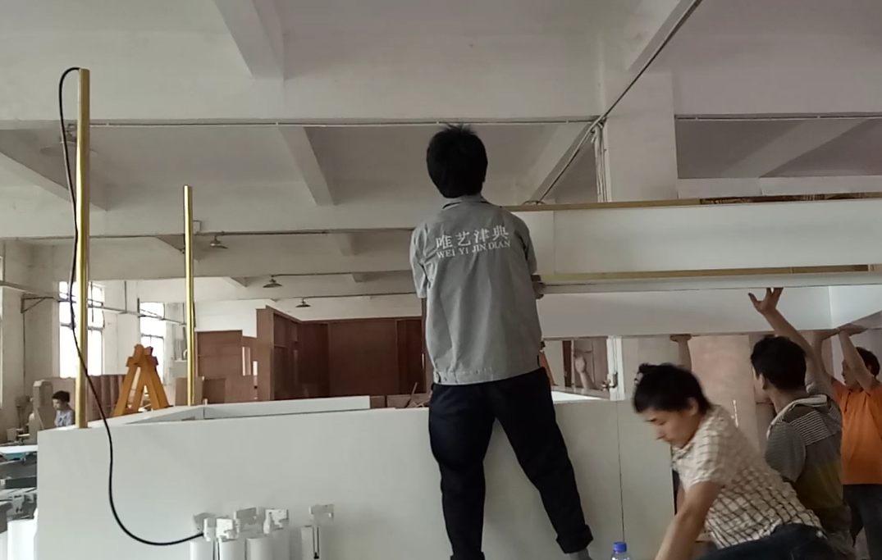
Second, move the roof to the top of wall. Needs 8 people.
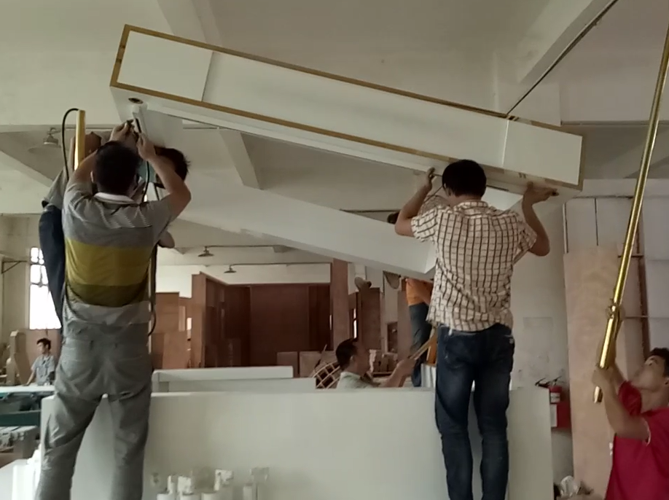
Third, when roof arrive the top, put another 2 pillars in the wall A.
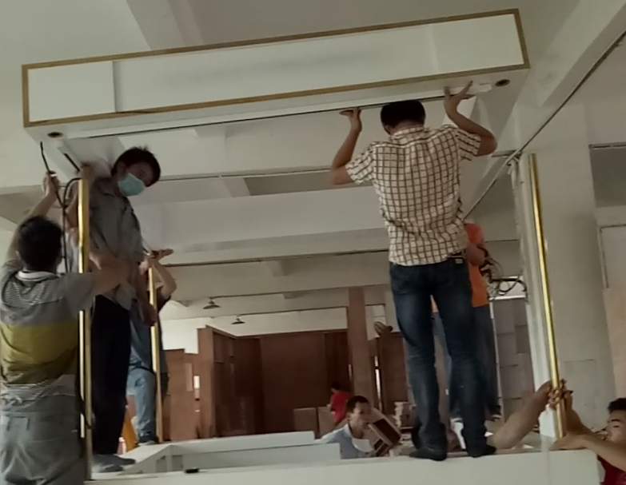
Fourth, pillar into roof holes,
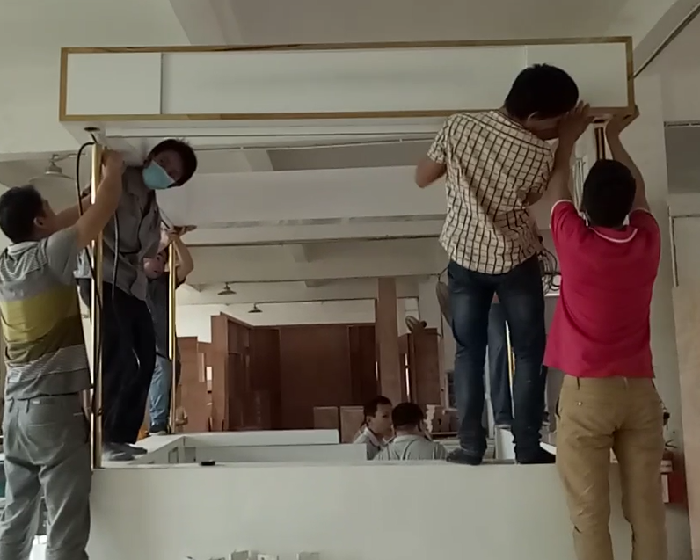
Remember to get the wire from pillar to roof.
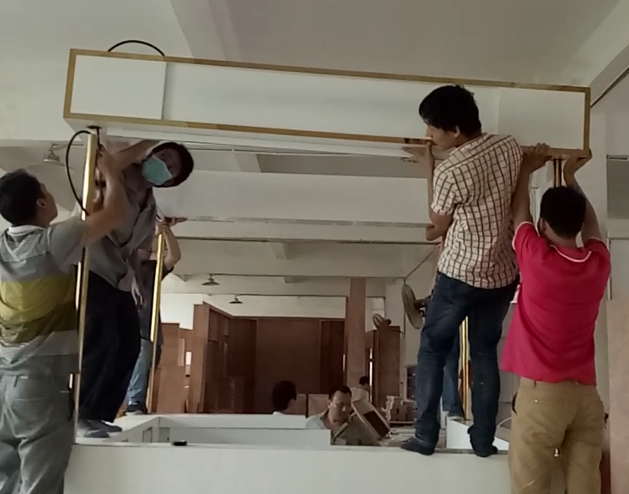
Pillar into both roof & wall holes. Make sure they are flat.
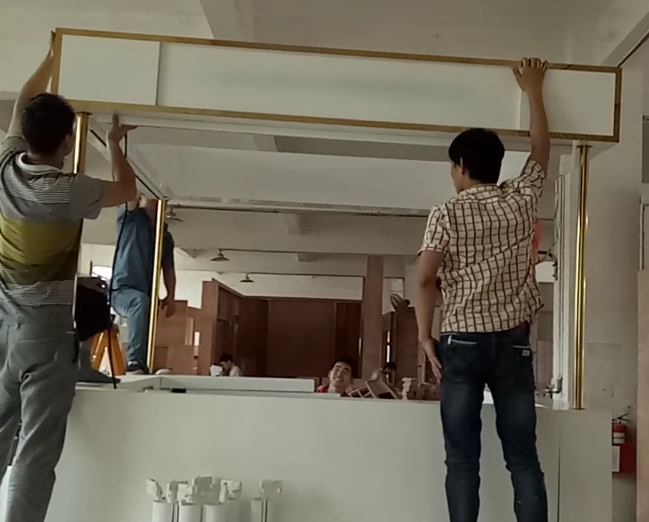
Screw both roof & wall.
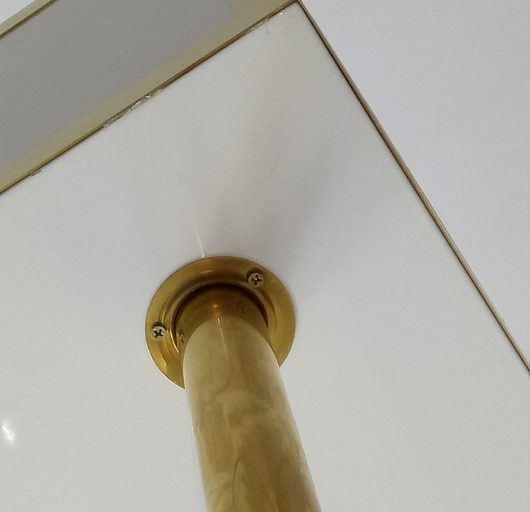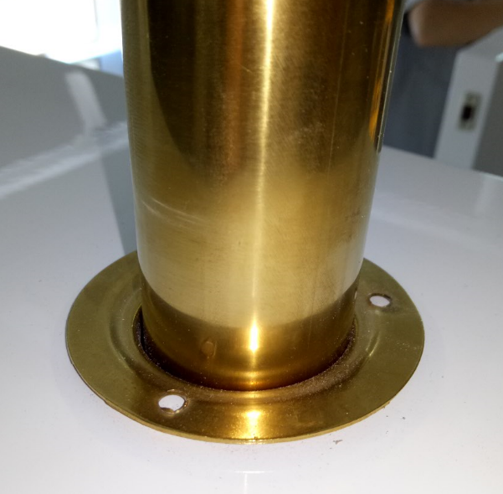
Finally, install track spotlights. See video for details. https://youtu.be/vgZGu012OmM
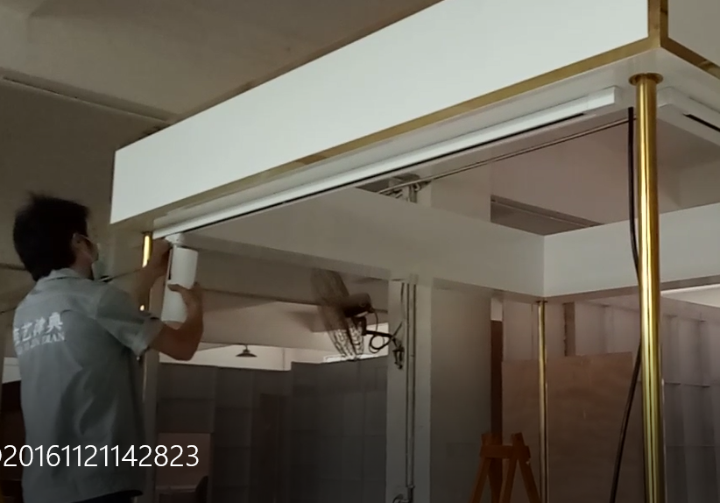
Put it into the track
Lock the spotlight, see photo below, and switch location in red circle.
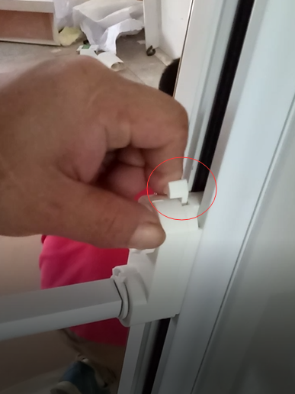

After you find the right location, turn the round button below to fix the lighting.
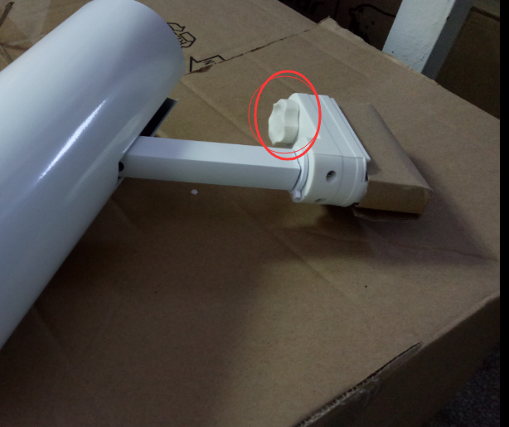

If you want to remove them, it is the same. Please switch to the right place before remove, or it may hurt the spotlight.
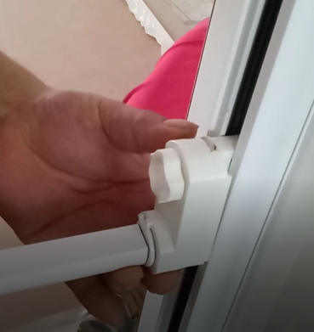
Counter Top installation
- Put units at right location, see photo below.
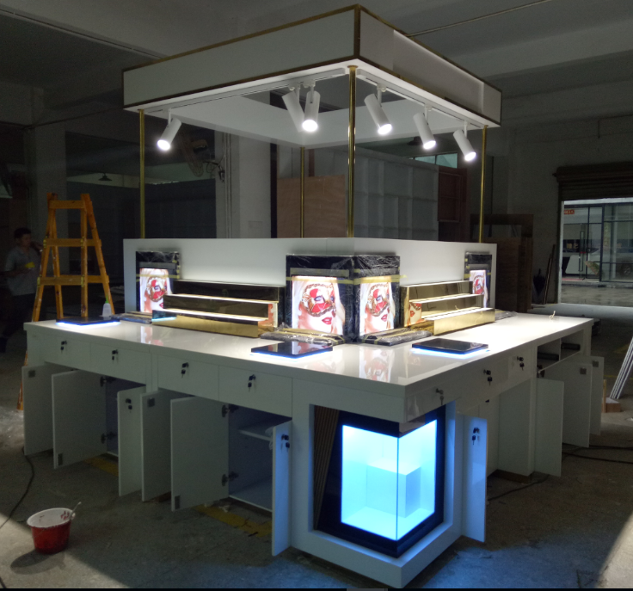

Those wires from holes for connecting display units. Not let it down the hole, or headache comes.
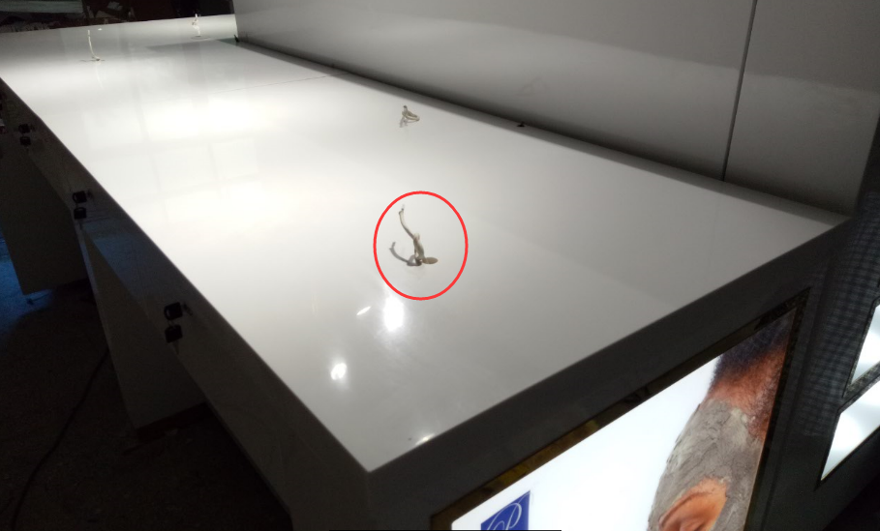
Acrylic display units connection.
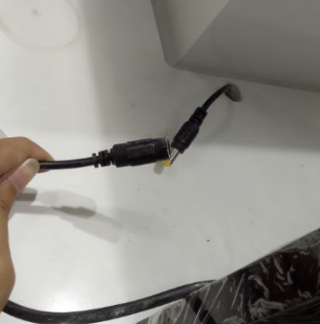
Black marble & step units connection.
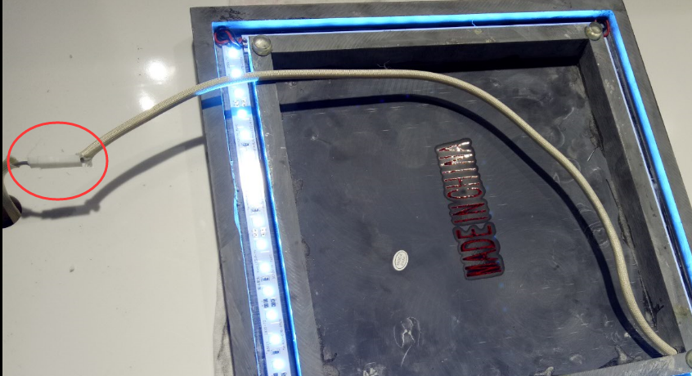

More installation photos to check
Disassemble： https://youtu.be/Gh0tn4IHjYU ， https://youtu.be/rYqJPzcw94s ， https://youtu.be/EC8tNwagZs8
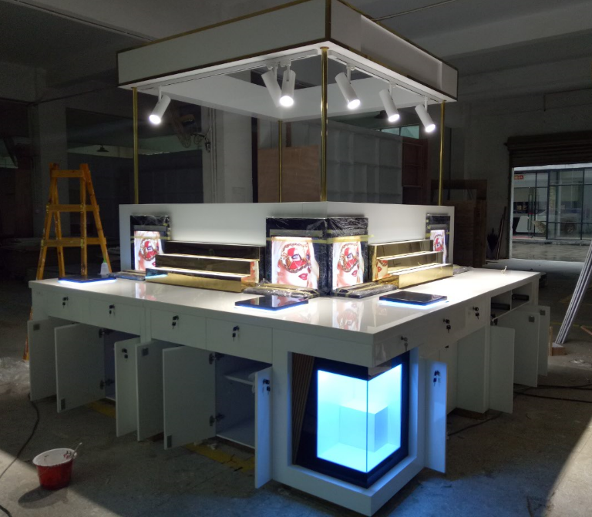
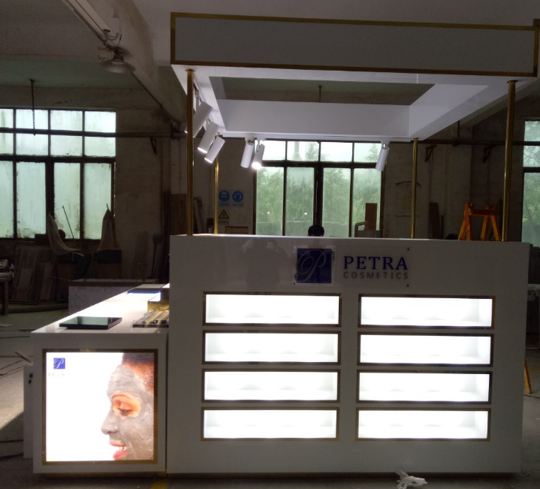
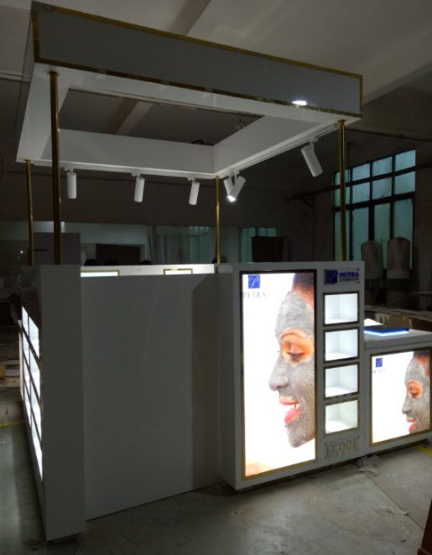
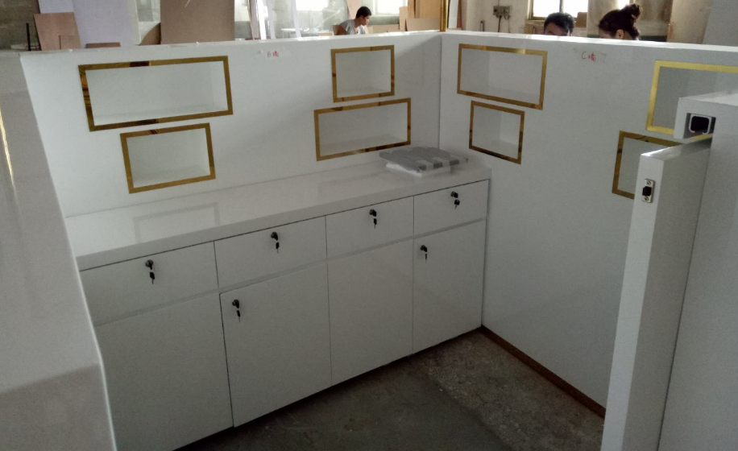
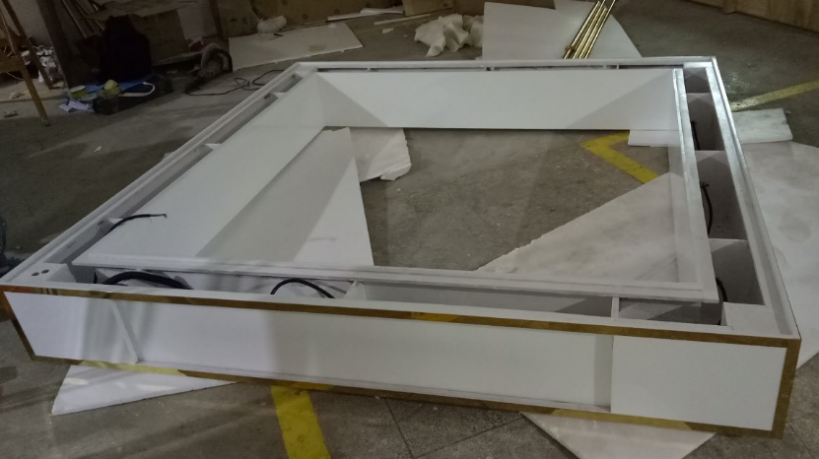
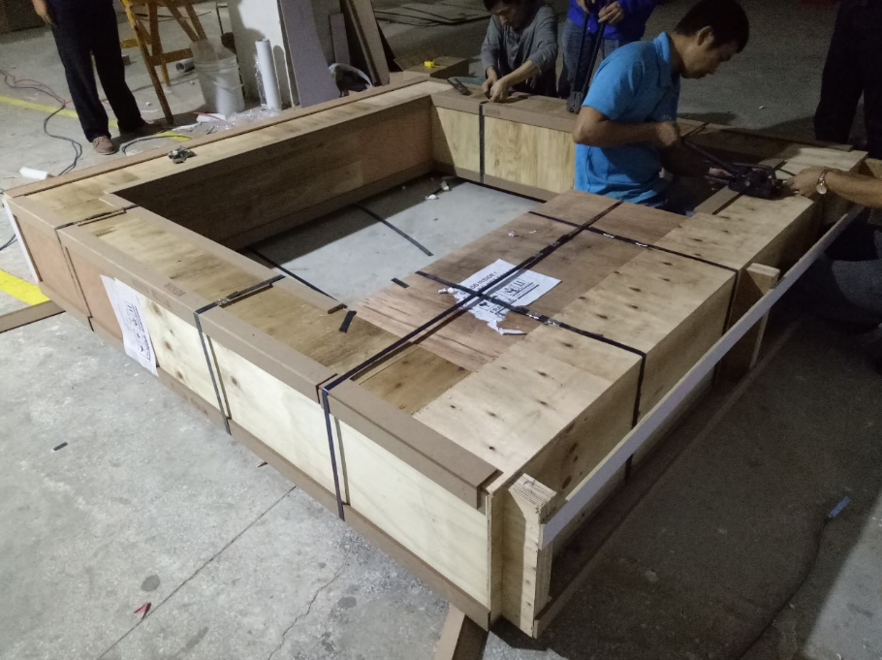
Cut the metal belt
